**Temple inns & Suites**

**Site Purpose**

The **Temple Inn & Suites** is a hotel chain headquartered in Bethesda, MD that builds and manages specialized hotel accommodations near temple locations of The Church of Jesus Christ of Latter-day Saints around the world. The owner-operated company caters to temple workers, patrons, and their families by providing specialized services and accommodations that meet the needs of those patrons. The hotel accommodations and services are available to anyone willing to abide by the terms and policies outlined by the company. The overall goal of the website project is to promote and provide information about the specialized services that this hotel chain offers to meet the needs of temple patrons who come to serve in the temple or who participate in events such as sealings, weddings, receptions, and youth trips. The website should reflect the Church culture and be designed to support a temple oriented theme as well as the concept of being a haven of comfort and accessibility. (From the Assignment overview on Canvas)

The domain name is: templeinnsuite.com

Temple Inn & Suites Logo



**Target Audience**

Who: Temple Patrons with lodging needs

Age: All ages

Income: $0-$1,000,000 per year

Motivation: To give long distance and long-term temple patrons a nice place to stay

**Scenarios**

1. As a Temple Patron I want to be able to have a nice place to stay when visiting the temple
2. As a Long-Term Temple Patron, I want a nice place for a long time with long term amenities
3. As a Temple inn and Suite’s user I want to be able to see the amenities available
4. As a Temple inn and Suite’s user I want to be able to make a reservation

**Site Map**

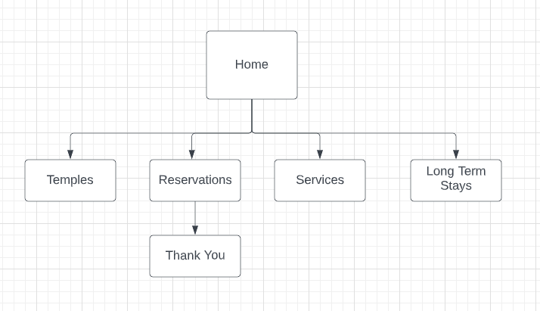

**Style Guide**

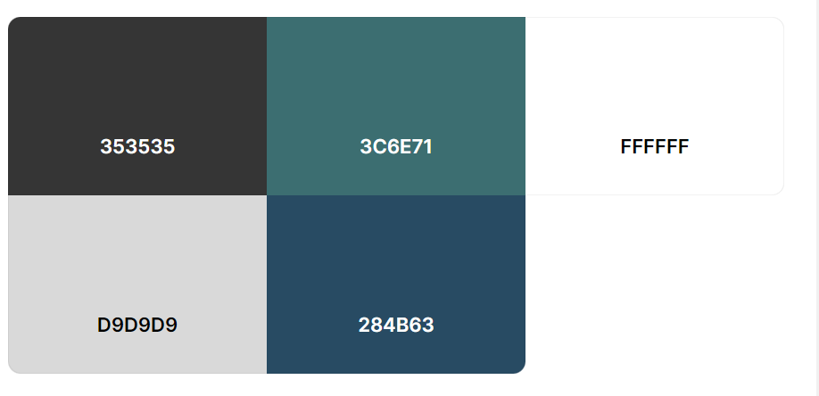

**Wireframes**

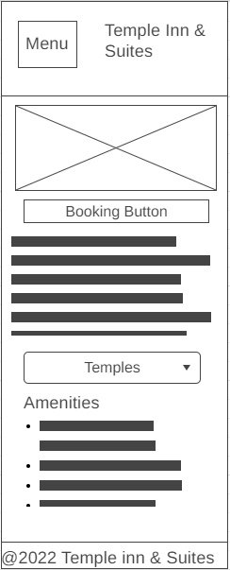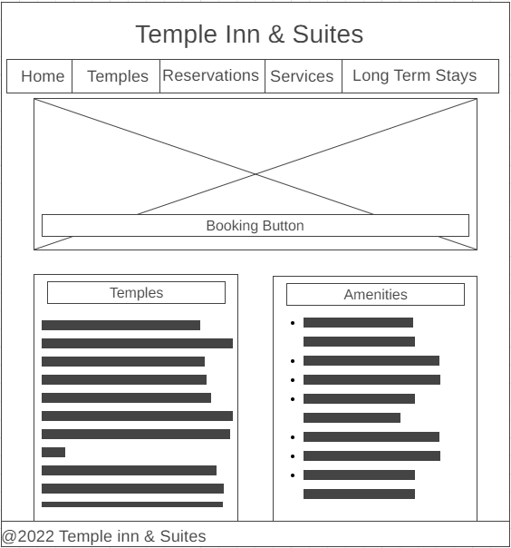

**Small Medium**

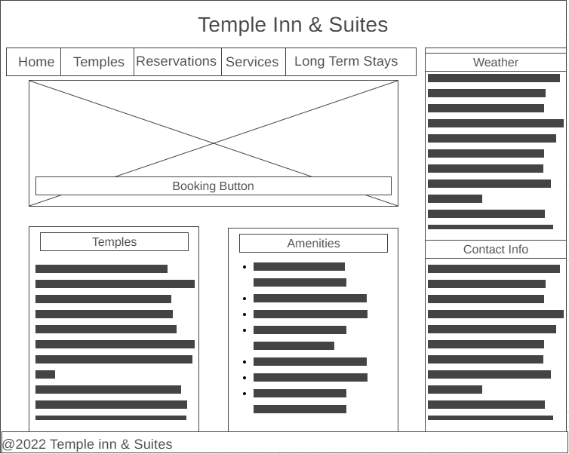

**Large**

**Typography**

